**Report**

1. 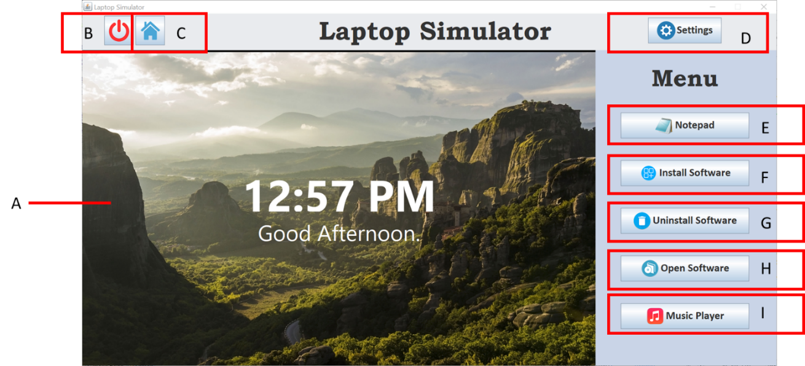**Introduction**

Laptop Simulator is an application that simulates a real laptop. It covers the basic functions of a laptop.

For the A – is display screen. B – Is the on/off button, which can start and close the screen. Besides that, C – is the home page button, when we click into others software, if we need to go back to main page, we can just click the home page button. Next is D – which is the settings button. This button can change the wallpaper of the screen and check the description for the system information. E – Is the Notepad that enables users to record notes in the database as well as displaying the note on the screen of Laptop Simulator. After that, the F and G that is Install Software button and Uninstall Software button. Install Software interface will show the description of each application and user can choose to install their preferred software in the list. Uninstall Software interface enable user to uninstall the installed software in the Laptop Simulator. Furthermore, H – Is the Open Software button that the function can open the software which user has installed. Lastly is I – This is the music player button, which can let user play their favourite music and add their favourite music to the playlist.

1. **UML class diagram and designs for the GUIs**



1. **A description of how you designed and developed the final code**

We used object oriented programming method to develop this application. Each function in the application is develop separated by using classes. Each of the class inherits the JFrame class in order to develop the GUI of the application. The GUI components that we used included JButton, JLabel, JTextArea, JPanel and so on. This application also consists of action listeners, which always listen to the action performed by the user, such as click on the button.

We also linked our application to a database by using DBHandler class with some imported external libraries given by lecturer. In the DBHandler class, there are methods that perform different SQL queries, such as SELECT from table and DELETE from table. Each queries are placed inside a try block as the execute query function may throw an exception when there is any error. When there is error while executing the query, the method will return a false and an error message will pop out to alert the user.

This application also included some additional classes in order to enhance the user experience. For example, we imported classes that needed in order to show current time in the application, such as “SimpleDateFormat”, “Calendar” and “Date”. We also included open source MP3 library in our project so that our application is able to play, pause and stop music files. We imported the classes needed for file chooser in order to allow user to upload images for wallpaper and MP3 files for music player.

1. **Suitable screen shots of the program in operation**

Figure 1 Laptop Simulator starting up with start-up animation

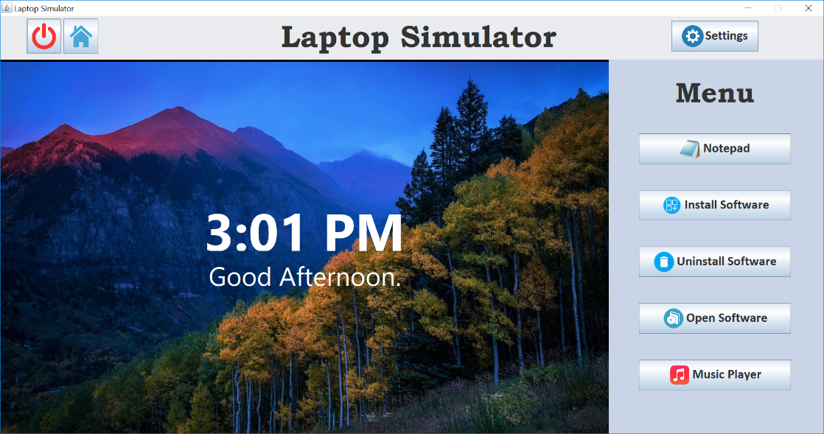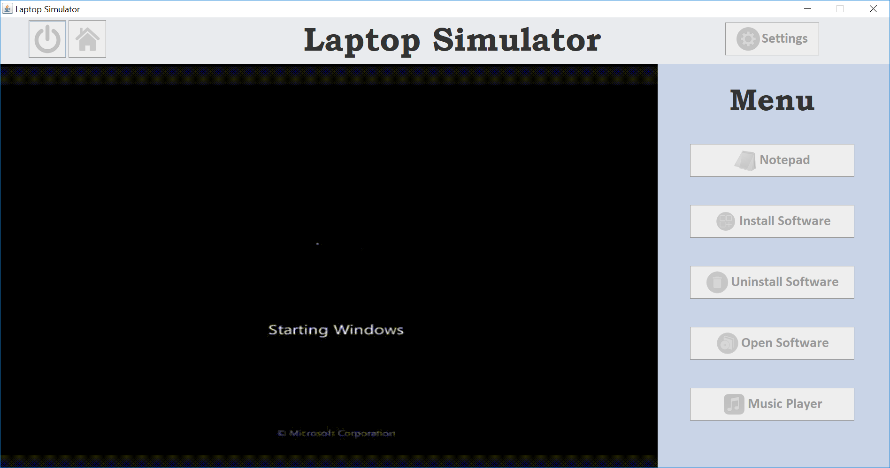

Figure 2 Home page of application

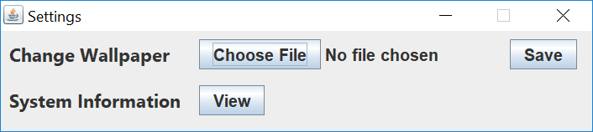

Figure 3 Settings interface

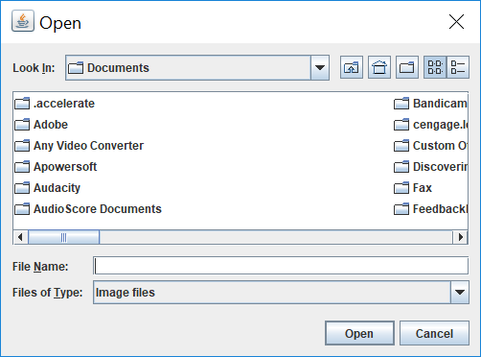

Figure 4 File Chooser interface

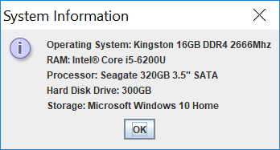

Figure 5 System Information interface

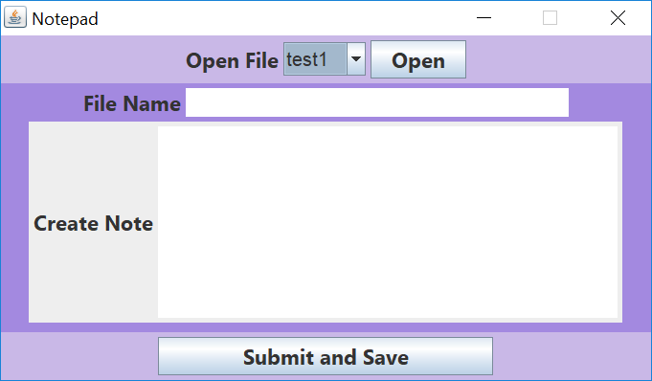

Figure 6 Notepad interface

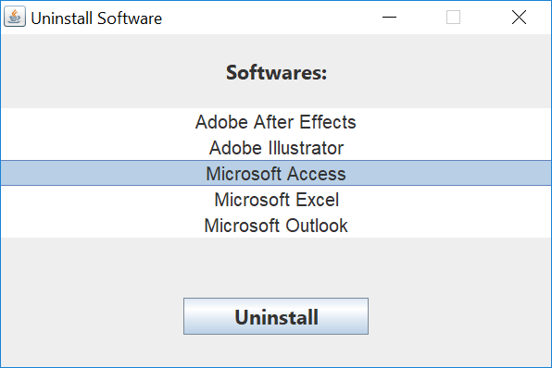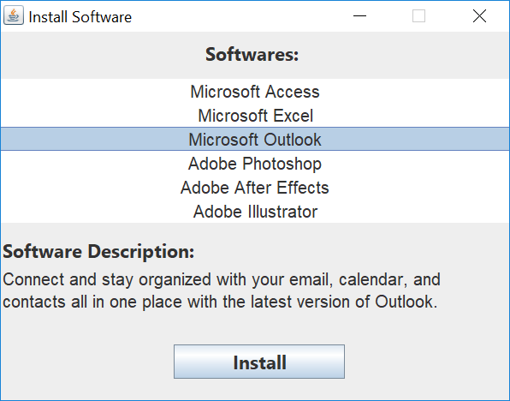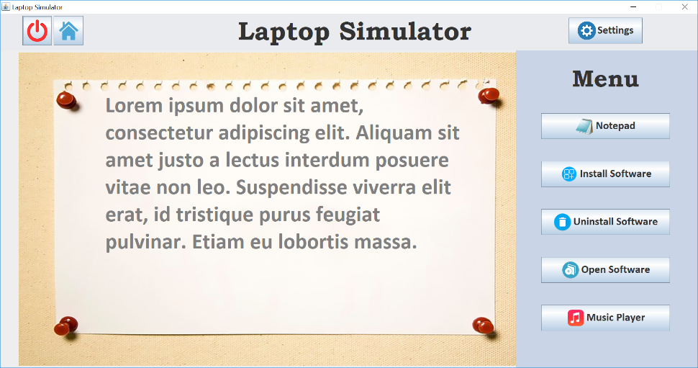

Figure 9 Uninstall Software interface

Figure 8 Install Software interface

Figure 7 Notepad’s text displayed on the screen

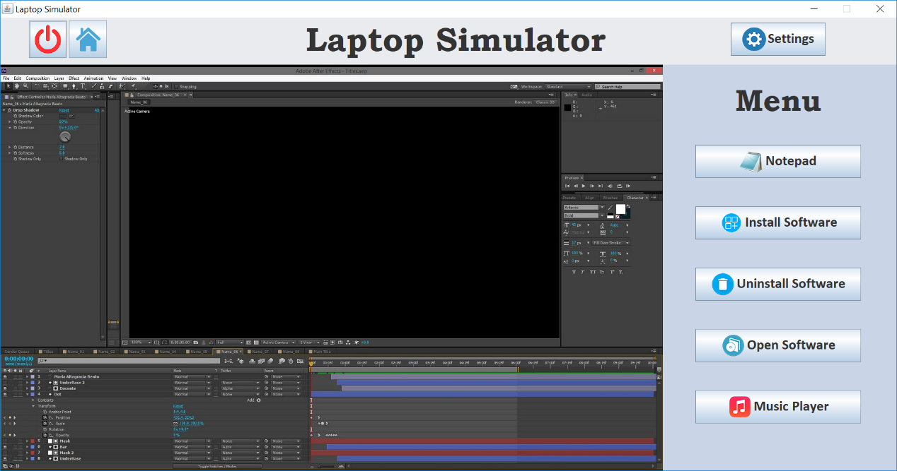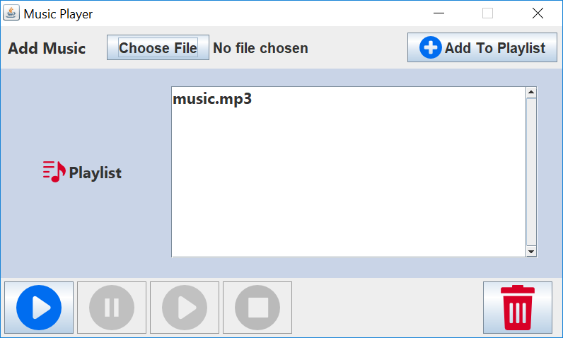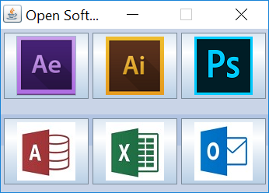

Figure 11 Software opened appeared on screen

Figure 12 Music Player interface

Figure 10 Open Software interface

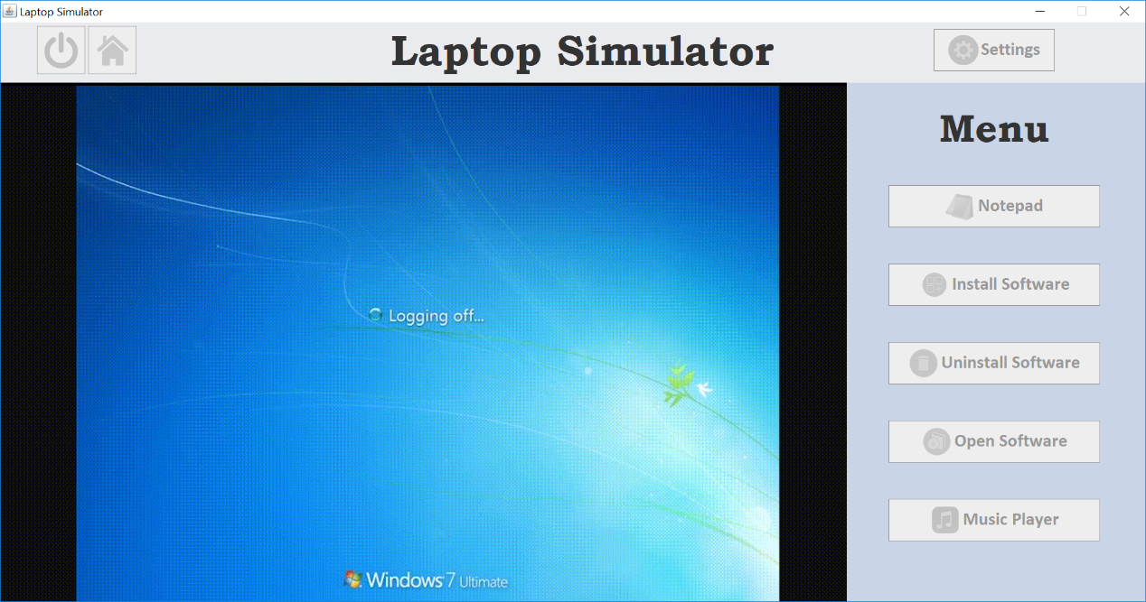

Figure 13 Laptop Simulator shutting down with shut down animation

1. **Details of any faults and failures, strengths of your system**

The faults of this application is it has a slow response and execution speed on running a class. This may be caused by importation of various built-in classes and external libraries as well as redundancy of if-else statements. This application also not able to store the wallpaper location chose by the user once it change to another wallpaper as the database table always store only one record. For the notepad, users are not able to delete the saved note in the database. For install software function, users can only install the software listed on the list and adding of other software are not supported by the application. For the music player, there is no “Next” and “Back” button that enable users to play next song or previous song in the playlist.

The strength of the application is it can display the current time on the screen and the greetings (“Good Afternoon”) will be changed according to the time. For example, when the time is 10AM, the greeting will be “Good Morning”. Besides, the wallpaper changed by the user will be preserved even the application is closed and restarted again as the wallpaper location will be store in the database. For software install function, users are able to read the description of the software while clicking on the item in the list. Users can also store the note written on the notepad in the database and they can open the note in the future. For music player, users can add and delete songs in the playlist and the item in the playlist will also be stored in the database.

1. **Conclusions and self-evaluation.**

Laptop Simulator is developed to simulate the actual laptop interface as close as possible. Users are able to perform basic functions on this application without worrying they will cause any error that damage the computer. Users can experience how actually a laptop works and function by using this application. In order to develop this system, all of team members had worked hard in order to build up each function of the simulator. We had learnt much as we tried and researches for different way to implement the code in our application.

***Self-evaluation***

**Name: Lee You Chen**

What I did in this assignment or able to learn in this assignment is the knowledge and a laptop demo skill with Java. I also learn about learn about how to link the java to database and having a good function there in the project.

The most difficult parts for me is how to link the database to the java and it still can function. So that, on that part I need my teammates to help me and honestly I have in a good team because we will help each other and will find a time to do together. At start I have not many idea on how to connect or link them together. After I search from internet and find my teammate to help only solve this problem.

For me the straightforward parts is the design part I know how to put the thing or where to put the button and label in a good looking place. I find that in easy because teacher have teach us before so that I can display it out easily. And also I know how to give people have a good look for the display part.

In this assignment I know or learn the GUI and linking skill. I this assignment I this the most important is need to link all the teammate thing together. So that the people must learn how to link the thing together and I also having some good connection idea. Other than that I have some knowledge on how to using Java in a good ways.

**Name: Bok Chou Zheng**

My report is telling about what I had done in this assignment. For our assignment project is doing a laptop simulator which can let user to experience what laptop’s application that’s work. My part is design and create the install and uninstalls software. The function for install is that may let user choose some software example Adobe Premiere Pro, Adobe Photoshop and then installing into the laptop. Besides that, for the uninstall part is that user may uninstall the software which user had install then software will clear in database. This is basically what my part will do in this assignment.

At the beginning, my teammate had created a main page which had some button that also including my install and uninstall software buttons. So, I just have to create the GUI inside the install and uninstall button. When came to inside, first I had created a selection box which can let user choose the software which need to install. Then I also had created a label which link to the database to show the description of the software. Next, I had created an install button to let user click and installing the software, so after user click the install button it will direct save into the database. This is the installing part.

Furthermore, when came to the uninstall part which are similar as the install part, but the difference is just it can let user to uninstall software from database. So, at first, I had created a selection box for user to select the software which need to uninstall. Then create a uninstall button to let user click. After clicking the uninstall button, the software which user had selected will delete in database. That all the things that I had done in my part and some of the coding that I don’t know, my friend will helping me write also.

**Name: Ng Yuan Shen**

By developing this application, I learnt how to create GUI for Java application and connect the application with database. My responsibilities in this project is to develop the MP3 player and manage the whole system. By developing the MP3 player, I learnt how to find external libraries for my project and implement it in the system. I also make use of various layout manager to implement different layout for GUI components.

The most difficult part of developing this application is the music player. This is because Java does not have built-in classes that can play and pause an audio file. Therefore, I searched for the suitable open source external library to play the audio file. I had tried different libraries for the music player and finally there is one that works. I also have to learn about using thread in Java in order to suspend (pause) the audio file.

The part that most straightforward is creating methods for database queries. I find these easy because the sample methods are provided by lecturers and I only have to modify some of the codes.

I was able to develop my skills by doing this project, as Laptop Simulator is a quite challenging application that less people tried it before. I did researches from the internet to find the ways to implement the function of the application in my coding. I keep trying different methods in order to develop codes that function as I expected.

**Name: Chin See Ying**

From this assignment, I have learnt about linking database with graphic user interface (GUI). My part was to create the notepad and the installation of software interface and functions. First, I learnt how to create the draft of the output of my part, which are two different user interfaces. Second, I learnt to create objects and also by using JFrame class to create and align the objects, such as the graphics, text and text boxes. Besides, I also learnt to create the user interface using GUI coding instead of drag and drop items. Therefore, I learnt some important keywords used in the library of the JFrame class. I also learnt to align the objects to the user interface that I had drafted before. I also learnt how to get data from the database and displayed out on the user interface of java. I also learnt how to insert the data from the user input to the database. I wrote several functions of linking database to the java application on selecting and inserting the data. Therefore, our applications are all linked to the database. I also learnt about using the switch case and for loop method to check the user input.